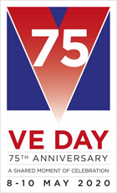
01/05/2020
Dear Participants,
RE: VE DAY 75 - 8TH MAY 2020.
After nearly eighteen months of planning, I find it hard to believe that we are just a few days away from the 75th Anniversary of VE Day, the end of the War in Europe.
However, like so many thousands of communities and individuals throughout our great nation, I am disappointed we are all unable to celebrate this important milestone in history in the wonderful ways we all planned, along with using this opportunity to raise valuable funds for SSAFA, the Armed Forces Charity. I will be thinking of you when my wife and myself raise our glasses of refreshment and undertake the ‘Nation’s Toast to the Heroes of WW II,’ at 3pm on the 8th May, this national moment of gratitude to those that gave so much during the war in Europe, from the safety of our front garden at home. We will also be using the ‘Toast’ to say a big thank you to you too for all the hard work and commitment you have shown and given to VE Day 75.
We both hope that you and your families will also take part in the ‘Nation’s Toast’ at 3pmfrom the safety of your home linking us all together in this unique tribute to the millions at home and abroad that gave so much to ensure we all enjoy and share the freedom we have today.
I am delighted to announce that Dame Joan Collins has kindly agreed to lead the ‘Toast’ on behalf of the women of the nation from the safety of her balcony from her London apartment. Dame Joan was a young girl living in London during WW II.
I would also like to take this opportunity to thank all the Buglers that have agreed to still play the Last Post at 2.55pm, the thousand plus Pipers undertaking Battle’s O’er and VE 75 years at the original time of 3pm, and the Town Criers who will be ‘Crying out for Peace,’ at 6.55pm. This will all happen from the safety of their homes to ensure we are still remembering the members of our Armed Forces, the Merchant Navy and those millions of others that had to stay at home to keep the “home fires burning" during those extremely difficult times.
As you know, SSAFA were our chosen charity for VE Day 75 and they, like us all, had heavy hearts when we had to cancel many of the VE Day 75 activities because of the Covid-19 pandemic and will not see them fully realised. However, SSAFA is also encouraging everyone to join with their staff, volunteers and beneficiaries in the Nation’s Toast at 3pm on 8th May paying tribute to the heroes of WW II including the 20,000 SSAFA volunteers who during WW II provided welfare support, nursing care at home and on the frontline around the world. If you would like to learn more about SSAFA’s role in WW II, and hear stories of the wartime generation please visit www.ssafa.org.uk/veday75 where you will also find further ideas about how to mark the 75th anniversary of VE Day whilst staying at home.
The Royal British Legion is calling on people across the UK to join in a moment of reflection and Remembrance at 11am on Friday 8th May, the 75th Anniversary of VE Day, and pause for a Two Minute Silence. I hope that you will also be able to support this important aspect of VE Day from home too.
"I hope you all remain safe.”
My warmest regards.
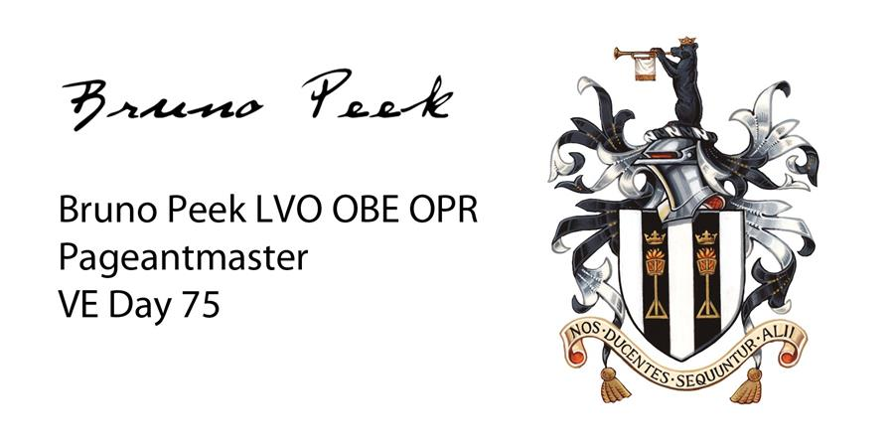

Bruno Peek LVO OBE OPR
Pageantmaster VE Day 75
Tel: + 44 (0) 7737 262 913
Email: pageantmaster@veday75.org

